CSA0603-Design-and-analysis-of-algorithms
1: First Palindromic String in an Array and find its completity
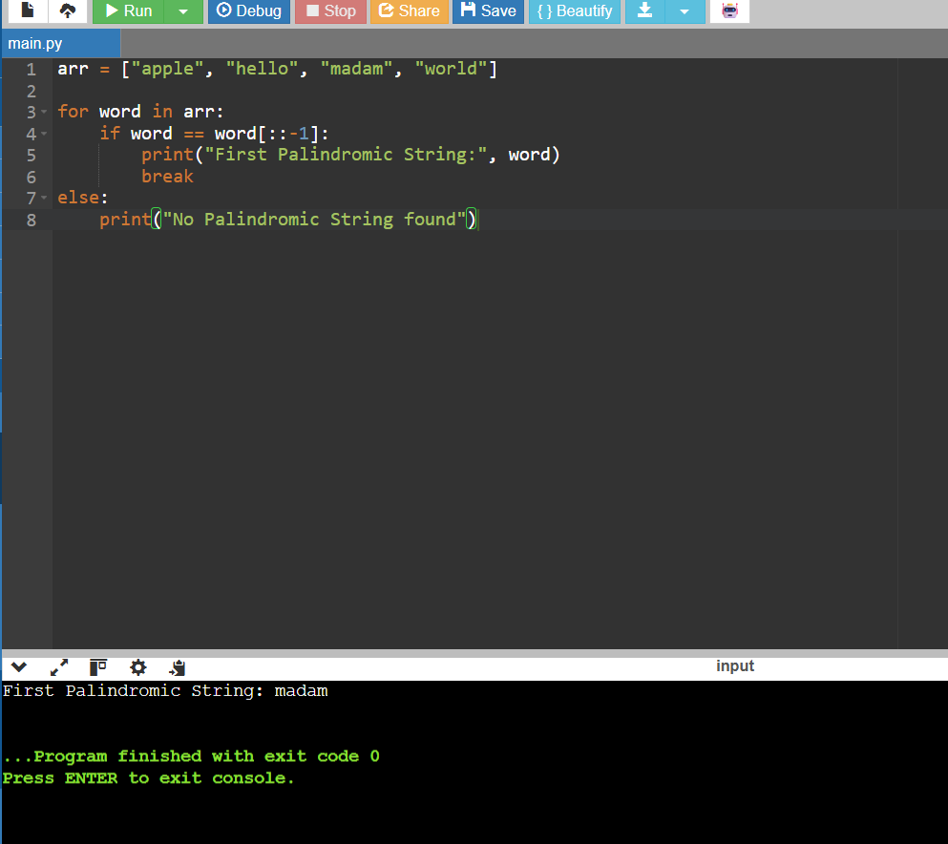

2: Common Elements Between Two Arrays and find its completity
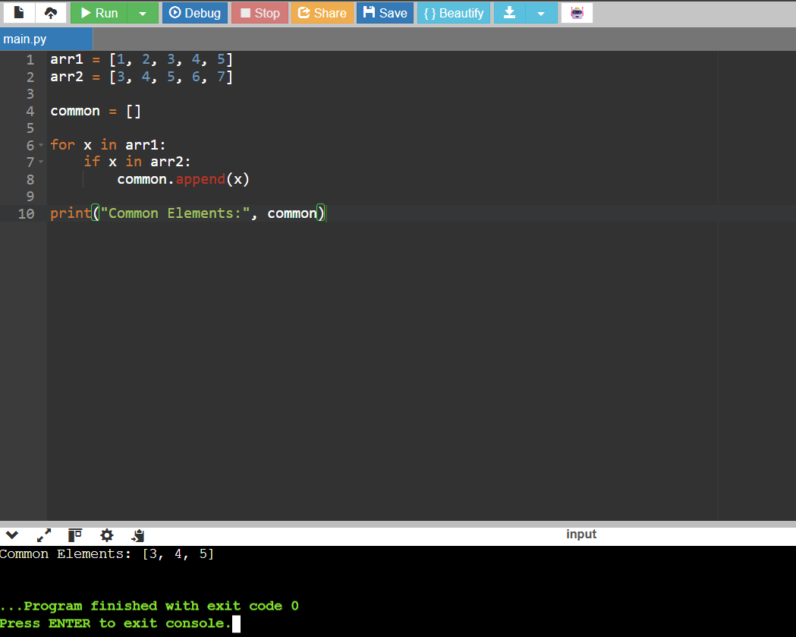

3: Subarrays Distinct Element Sum of Squares
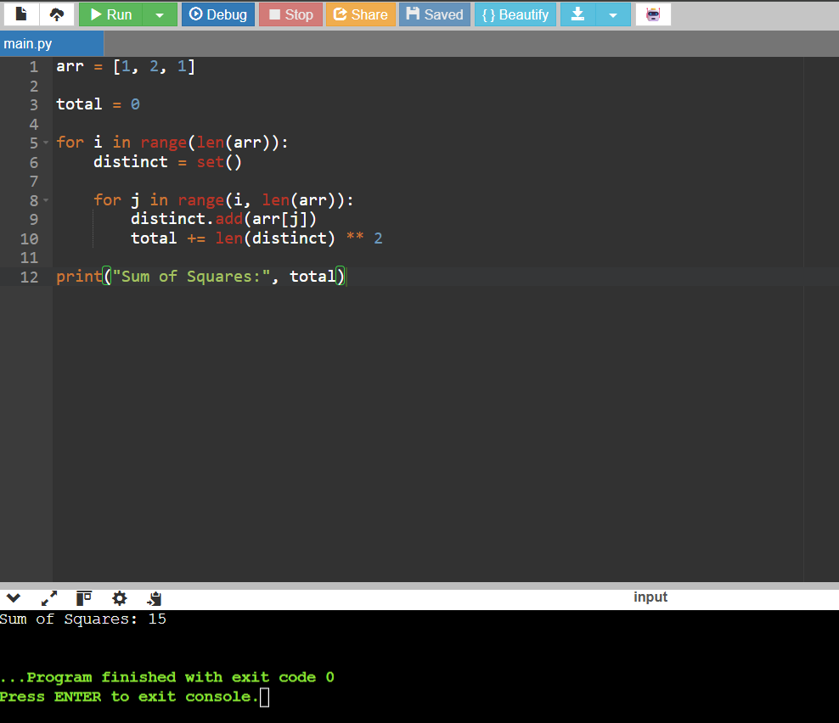

4: Count Equal and Divisible Pairs in an Array
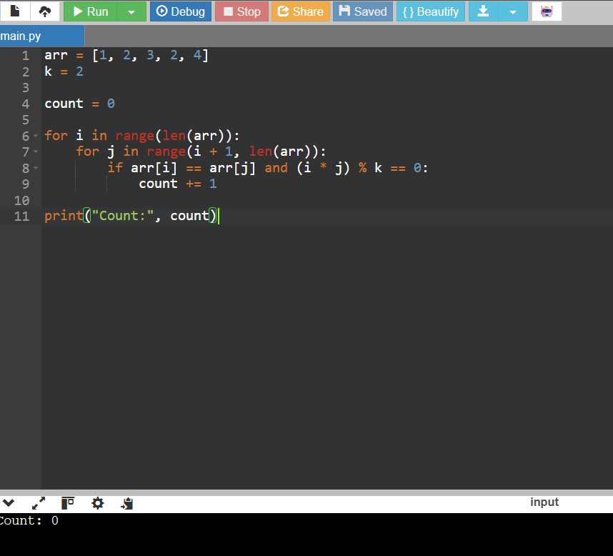

Exp 5: Maximum Element with Least Time Complexity
